**AngularJS Demo App**

**Software used:**

1. Visual Studio CODE (VS CODE):
2. Node.js
3. Mongo dB

1. Visual Studio Code:

VS Code is a free code editor which runs on the macOS, Linux and Windows operating systems. VS Code is lightweight and should run on most available hardware and platform versions.

Download link:-<https://code.visualstudio.com/download>

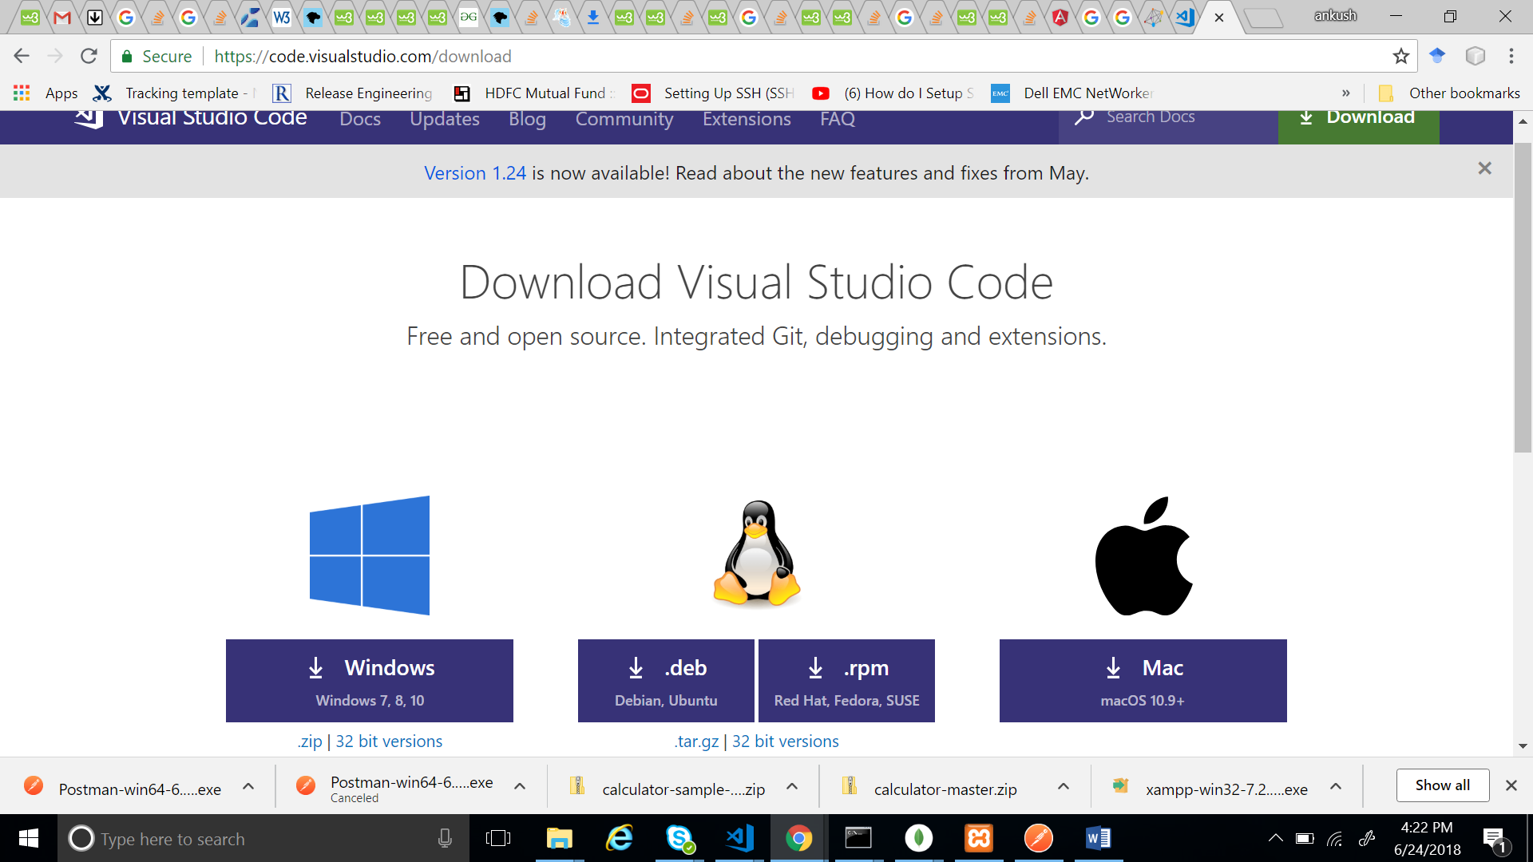

Installation:-

1. Download the Visual Studio Code msi from the above link.
2. Once it is downloaded, run the installer (VSCodeSetup-version.exe). This will only take a minute.
3. By default, VS Code is installed under C:\Program Files\Microsoft VS Code for a 64-bit

The richness of support varies across the different languages and their extensions:

* Syntax highlighting and bracket matching
* Smart completions (IntelliSense)
* Linting and corrections
* Code navigation (Go to Definition, Find All References)

Additional components required for running java script application in VS code:

Node.js (includes NPM):- A platform and runtime for building and running JavaScript applications.

**2. Node.JS:**

Node.js is a platform for building fast and scalable server applications using JavaScript. Node.js is the runtime and NPM is the Package Manager for Node.js modules. However, to run a Node.js application, you will need to install the Node.js runtime on your machine.

Download link: <https://nodejs.org/en/>

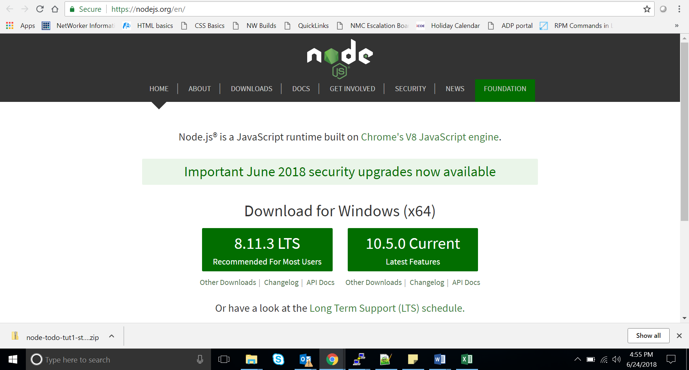

Installation steps:

1. From the above link download Node.js for Windows by clicking the "Windows Installer" option
2. Run the downloaded Node.js .msi Installer - including accepting the license, selecting the destination, and authenticating for the install.
3. This requires Administrator privileges, and you may need to authenticate
4. To ensure Node.js has been installed, run node -v in your terminal - you should get something like v6.9.5
5. Update your version of npm with npm install npm --global
6. This requires Administrator privileges, and you may need to authenticate.
7. **Mongo DB:**

MongoDB is an open-source document database and leading NoSQL database. MongoDB is a cross-platform, document oriented database that provides, high performance, high availability, and easy scalability. MongoDB works on concept of collection and document.

Download link: <https://www.mongodb.com/download-center?#community>

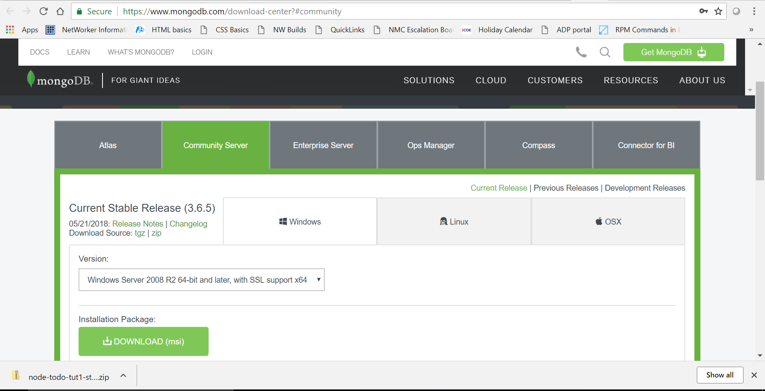

Installation steps:-

1. Install on Windows 7 / Server 2008 R2 or Later .MongoDB Enterprise Edition requires Microsoft Windows Server 2008 R2 or later or Microsoft Windows 7 or later for the x86 64-bit architecture.
2. Create database and log directories.

MongoDB requires a data directory to store all data. MongoDB’s default data directory path is the absolute path \data\db. on the drive from which you start MongoDB.

3. Start your MongoDB database.

->To start MongoDB, invoke mongod.exe.

->"C:\Program Files\MongoDB\Server\3.6\bin\mongod.exe".

1. Command to start DB: net start MongoDB.
2. Command to stop DB: net stop MongoDB.

**NPM Modules for NodeJs.**

NPM is a package manager for Node.js packages, or modules.

To create package.json use command: npm init

To install other dependencies like:

1. npm install nodejs
2. npm install mongodb
3. npm install express
4. npm install body-parser
5. npm install fs.